TFM_E2_Grupo02

2023-06-08

## PROTEINS_100G 0.867 0.007 |

fviz_eig(seitan_pca, ncp = 6, addlabels = T, main = "Variance explained by each dimensions - Seitan")

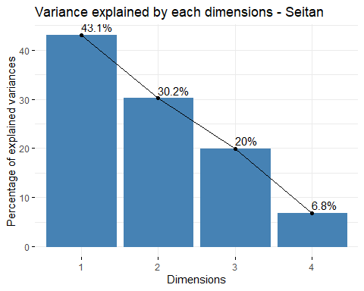

library(ggthemes)  
seitan_a <- data.frame(seitan_pca$ind$coord[,1:3])  
seitan_b <- cbind(seitan_a, lof_score = seitan_lof)  
#seitan_b <- cbind(seitan_a, fraud = seitan_clean$, lof_score = seitan_clean$lof)  
  
seitan_lof_visual <- ggplot(seitan_b, aes(x=Dim.1 ,y=Dim.2)) +   
 geom_point(aes(size=lof_score)) +  
 ggtitle("LOF Score Distribution - Seitan")+  
 theme_minimal()  
  
seitan_lof_visual

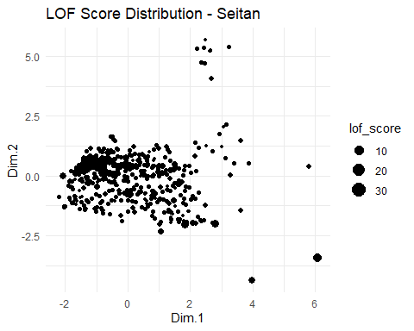

summary(seitan_b)

## Dim.1 Dim.2 Dim.3 lof_score   
## Min. :-2.2051 Min. :-4.37419 Min. :-8.2367 Min. :0.9126   
## 1st Qu.:-0.9834 1st Qu.:-0.68423 1st Qu.:-0.3688 1st Qu.:1.0014   
## Median :-0.3252 Median : 0.06254 Median :-0.0602 Median :1.0707   
## Mean : 0.0000 Mean : 0.00000 Mean : 0.0000 Mean : Inf   
## 3rd Qu.: 0.8360 3rd Qu.: 0.55616 3rd Qu.: 0.3935 3rd Qu.:1.2404   
## Max. : 6.0740 Max. : 5.68950 Max. : 5.4533 Max. : Inf

seitan_b %>%  
 filter(lof_score <= 1.75) %>%   
 ggplot( aes(x=lof_score)) +  
 geom_density( color="#e9ecef", fill = "#c90076", alpha=0.7) +  
 scale_fill_manual(values="#8fce00") +  
 xlab("LOF Score")+  
 ggtitle("LOF Score Distribution Seitan")+  
 theme_minimal() +  
 labs(fill="")

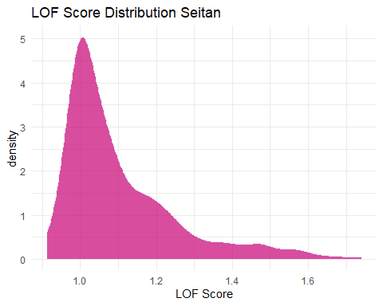

quantile(seitan_b$lof_score, probs = c(0, 0.8))

## 0% 80%   
## 0.9125573 1.3319969

seitan_b <- seitan_b %>%   
 mutate(outlier = ifelse(lof_score > 1.3319969, 1, 0))  
  
seitan_lof_visual_b <- ggplot(seitan_b, aes(x=Dim.1 ,y=Dim.2, color=outlier)) +   
 geom_point() +  
 ggtitle("LOF Score Distribution Seitan")+  
 theme_minimal()  
  
seitan_lof_visual_b

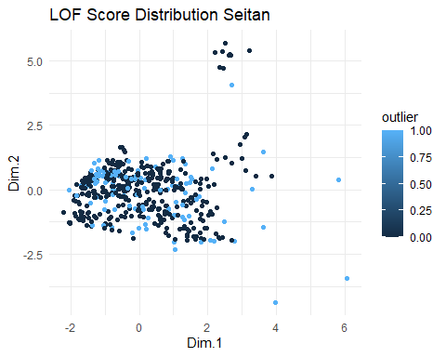

outliers <- seitan_b[seitan_b$outlier==1,]  
nooutliers <- seitan_b[seitan_b$outlier==0,]

df_seitan <- df_seitan[seitan_lof < 1.3319969,]  
df_seitan_outliers <- df_seitan[seitan_lof >= 1.3319969,]

# ELIMINAR ATIPICOS MULTIVARIANTES CON DBSCAN

# ELIMINAR ATIPICOS MULTIVARIANTES  
# lof_scores <- lof(df_seitan[c("ENERGY_100G","PROTEINS_100G", "CARBOHYDRATES_100G", "FAT_100G")], minPts = 6)  
# df_seitan <- df_seitan[lof_scores <= 1,]

# Eliminar valores atipicos univariantes

remove_outliers <- function(data, column, sd_threshold = 2) {  
 data[abs(scale(data[[column]])) < sd_threshold, ]  
}  
  
columns_to_check <- 3:ncol(df_seitan)  
for (column in columns_to_check) {  
 df_seitan <- remove_outliers(df_seitan, column)  
}

# Obtener las columnas cuantitativas del dataframe  
columnas_cuantitativas <- sapply(df_seitan, is.numeric)  
  
# Crear un histograma para cada columna cuantitativa  
for (columna in names(df_seitan[columnas_cuantitativas])) {  
 plot_data <- df_seitan[, columna]  
 p <- ggplot(data.frame(x = plot_data), aes(x)) +  
 geom_histogram(binwidth = 0.5, fill = "steelblue", color = "white") +  
 labs(title = paste("Histograma de", columna,"- Seitan"),  
 x = columna,  
 y = "Frecuencia")  
   
 print(p)  
}

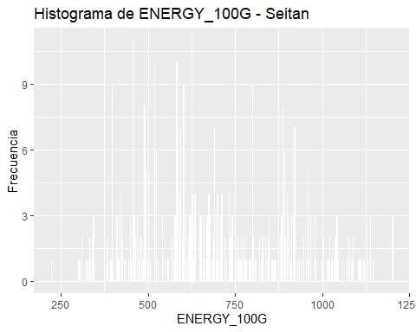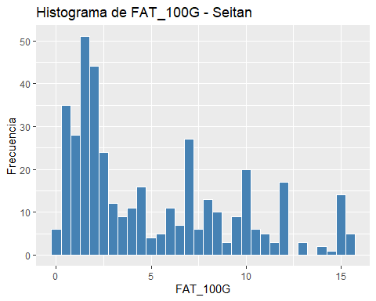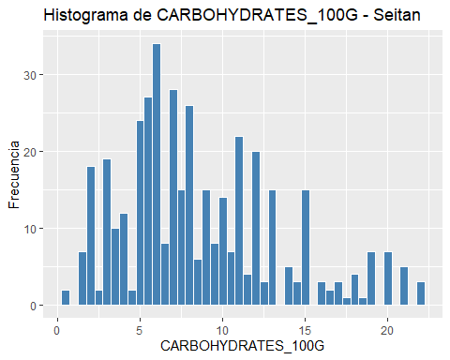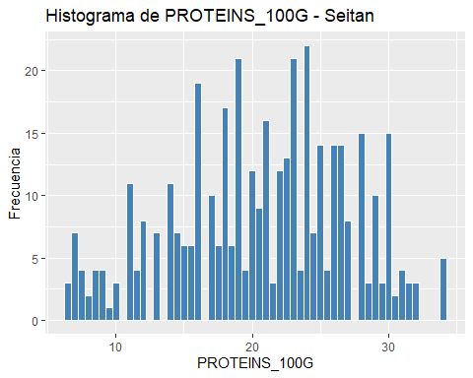

summary(as.data.frame(scale(df_seitan[,-1:-2])))

## ENERGY_100G FAT_100G CARBOHYDRATES_100G PROTEINS_100G   
## Min. :-2.1889 Min. :-1.1914 Min. :-1.7133 Min. :-2.2511   
## 1st Qu.:-0.8173 1st Qu.:-0.8407 1st Qu.:-0.6554 1st Qu.:-0.7415   
## Median :-0.1246 Median :-0.3731 Median :-0.2111 Median : 0.0448   
## Mean : 0.0000 Mean : 0.0000 Mean : 0.0000 Mean : 0.0000   
## 3rd Qu.: 0.8775 3rd Qu.: 0.7257 3rd Qu.: 0.5284 3rd Qu.: 0.7446   
## Max. : 2.3322 Max. : 2.4557 Max. : 2.8357 Max. : 2.0891

#Datos normalizados para el Seitán

s_seitan <- as.data.frame(scale(df_seitan[,-1:-2]))  
# Obtener las columnas cuantitativas del dataframe  
columnas_cuantitativas <- sapply(s_seitan, is.numeric)  
  
# Crear un histograma para cada columna cuantitativa  
for (columna in names(s_seitan[columnas_cuantitativas])) {  
 plot_data <- s_seitan[, columna]  
 p <- ggplot(data.frame(x = plot_data), aes(x)) +  
 geom_histogram(binwidth = 0.5, fill = "steelblue", color = "white") +  
 labs(title = paste("Histograma de", columna,"- Seitan"),  
 x = columna,  
 y = "Frecuencia")  
   
 print(p)  
}

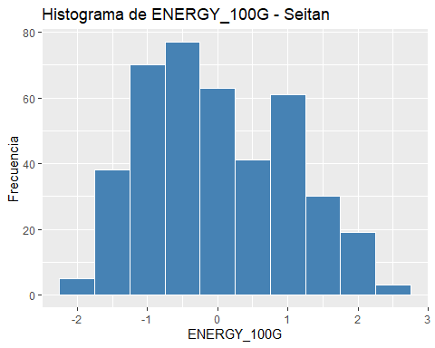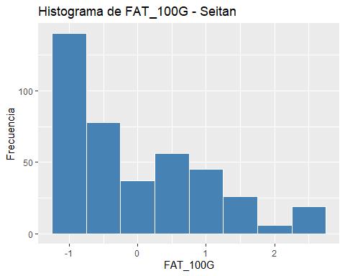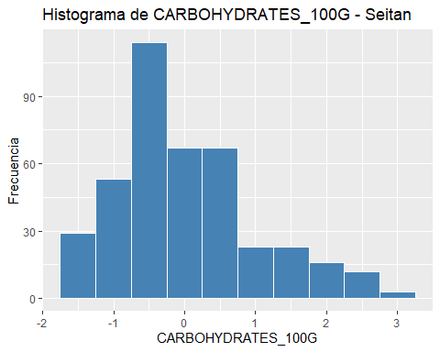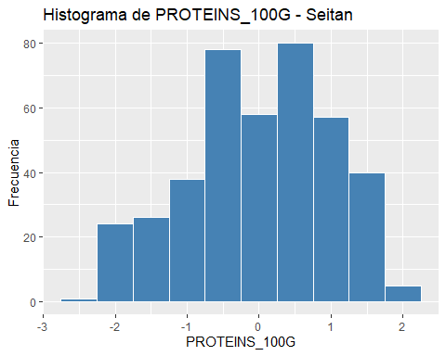

s_seitan <- scale(df_seitan[,-1:-2])  
  
# total de cluster óptimos  
elbow <- fviz_nbclust(x = s_seitan, FUNcluster = kmeans, method = "wss", k.max = 15,   
 diss = get_dist(s_seitan, method = "euclidean"), nstart = 25)  
print(elbow)

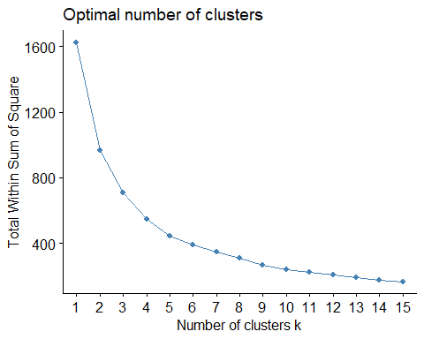

# set.seed(123)  
# km_clusters <- kmeans(x=s_seitan,centers=4,nstart=50)  
# fviz_cluster(object=km_clusters,data=s_seitan,show.clust.cent = TRUE,  
# ellipse.type="euclid",star.plot=TRUE,repel=TRUE,  
# pointsize=0.5,outlier.color="darkred") +  
# labs(title ="Resultados clustering K-means") +  
# theme_bw() +  
# theme(legend.position = "none")  
  
set.seed(123)  
km_clusters <- kmeans(x = s_seitan, centers = 4, nstart = 50)  
  
fviz_cluster(object = km_clusters, data = s_seitan, show.clust.cent = TRUE,  
 ellipse.type = "euclid", star.plot = TRUE, repel = TRUE,  
 pointsize = 0.5, outlier.color = "darkred", geom = "point") +  
 theme_bw() +  
 theme(legend.position = "none") +  
 ggtitle("Resultados clustering K-means Seitan")

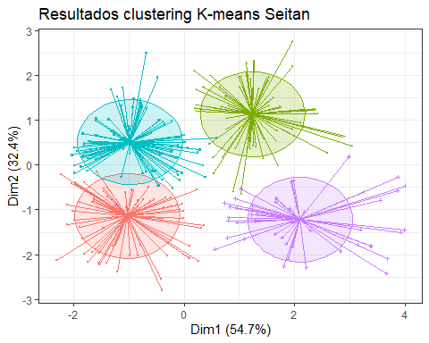

set.seed(101)  
  
hc_euclidea_av <- hclust(d = dist(x = s_seitan, method = "euclidean"),  
 method = "average")  
fviz_dend(x = hc_euclidea_av, k = 4, cex = 0.5,  
 k_colors = c("red","blue","green","magenta"),color_labels_by_k = T,  
 lwd = 0.2,type = "r",label_cols = rainbow(nrow(df_seitan)),  
 rect_lty = "lightblue") +  
 geom_hline(yintercept = 3.65, linetype = "dashed") +  
 labs(title = "Herarchical clustering Seitan",  
 subtitle = "Distancia euclidea, Average, k=4")

## Warning: The `<scale>` argument of `guides()` cannot be `FALSE`. Use "none" instead as  
## of ggplot2 3.3.4.  
## ℹ The deprecated feature was likely used in the factoextra package.  
## Please report the issue at <https://github.com/kassambara/factoextra/issues>.  
## This warning is displayed once every 8 hours.  
## Call `lifecycle::last_lifecycle_warnings()` to see where this warning was  
## generated.

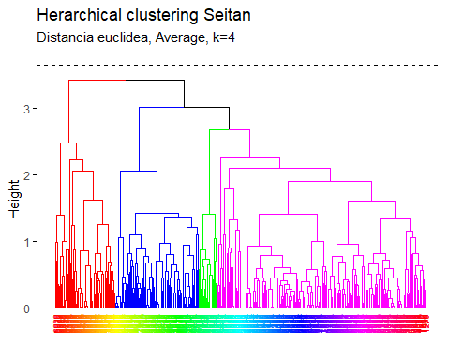

pam.res <- pam(s_seitan, 4)  
# Visualización  
fviz_cluster(pam.res, geom = "point", ellipse.type = "norm",  
 show.clust.cent = TRUE,star.plot = TRUE)+  
 labs(title = "Resultados clustering K-means superpuestos - Seitan")+ theme_bw()

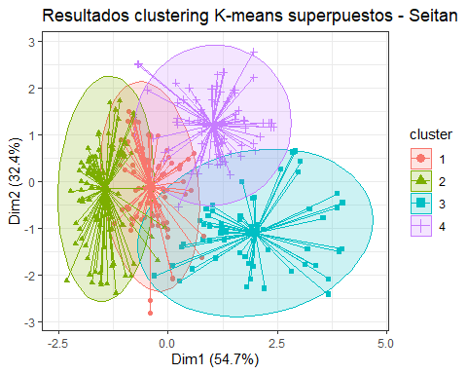

# Biplot PCA y K-Means para medir representatividad seitan

# PCA  
pca <- prcomp(df_seitan[,-1:-2], scale=TRUE)  
df_seitan.pca <- pca$x  
# Cluster over the three first PCA dimensions  
kc <- kmeans(df_seitan.pca[,1:3], 4)  
fviz_pca_biplot(pca, label="var", habillage=as.factor(kc$cluster)) +  
 labs(color=NULL) + ggtitle("") +  
 theme(text = element_text(size = 15),  
 panel.background = element_blank(),   
 panel.grid.major = element_blank(),  
 panel.grid.minor = element_blank(),  
 axis.line = element_line(colour = "black"),  
 legend.key = element_rect(fill = "white"))

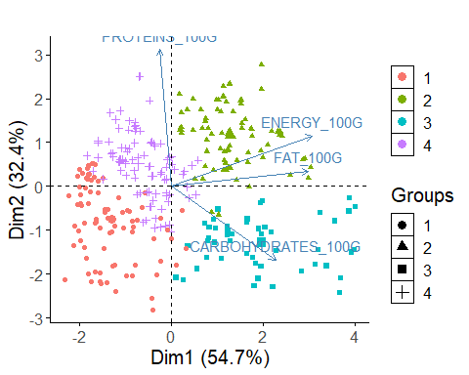

library(ggplot2)  
  
# Obtener los centroides de cada clúster  
centroids <- as.data.frame(km_clusters$centers)  
  
  
# Obtener el valor mínimo y máximo en el dataframe  
min_value <- min(centroids, na.rm = TRUE)  
max_value <- max(centroids, na.rm = TRUE)  
  
# Escalar los datos entre 0 y 1  
scaled_df <- (centroids - min_value) / (max_value - min_value)  
  
library(fmsb)

## Warning: package 'fmsb' was built under R version 4.3.1

# Define the variable ranges: maximum and minimum  
max_min <- data.frame(  
 ENERGY_100G = c(1, 0), FAT_100G = c(1, 0), CARBOHYDRATES_100G = c(1, 0),PROTEINS_100G = c(1, 0)  
)  
rownames(max_min) <- c("Max", "Min")  
  
# Bind the variable ranges to the data  
df <- rbind(max_min, scaled_df)

create_beautiful_radarchart <- function(data, color = "#00AFBB",   
 vlabels = colnames(data), vlcex = 0.7,  
 caxislabels = NULL, title = NULL, ...){  
 radarchart(  
 data, axistype = 1,  
 # Customize the polygon  
 pcol = color, pfcol = scales::alpha(color, 0.3), plwd = 2, plty = 1,  
 # Customize the grid  
 cglcol = "grey", cglty = 1, cglwd = 0.8,  
 # Customize the axis  
 axislabcol = "grey",   
 # Variable labels  
 vlcex = vlcex, vlabels = vlabels,  
 caxislabels = caxislabels, title = title, ...  
 )  
}

# Reduce plot margin using par()  
op <- par(mar = c(1, 2, 2, 1))  
create_beautiful_radarchart(df, caxislabels = c(0, .25, .5, .75, 1))

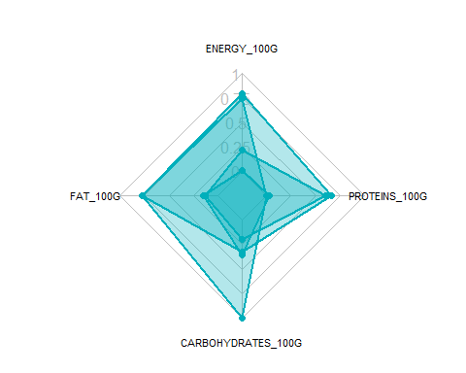

par(op)

# Reduce plot margin using par()  
op <- par(mar = c(1, 2, 2, 2))  
# Create the radar charts  
create_beautiful_radarchart(  
 data = df, caxislabels = c(0, .25, .5, .75, 1),  
 color = c("#00AFBB", "#E7B800", "#FC4E07","#7A378B")  
)  
# Add an horizontal legend  
legend(  
 x = "bottom", legend = rownames(df[-c(1,2),]), horiz = TRUE,  
 bty = "n", pch = 20 , col = c("#00AFBB", "#E7B800", "#FC4E07","#7A378B"),  
 text.col = "black", cex = 1, pt.cex = 1.5  
 )

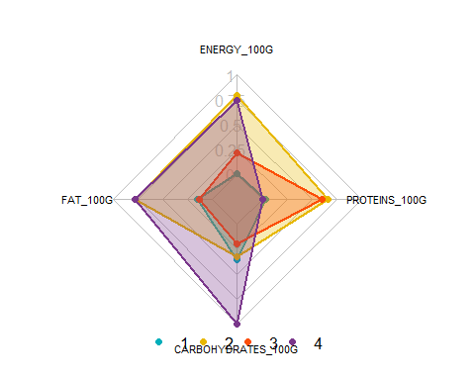

par(op)

# Define colors and titles  
colors <- c("#00AFBB", "#E7B800", "#FC4E07","blue")  
titles <- c("1", "2", "3","4")  
  
# Reduce plot margin using par()  
# Split the screen in 3 parts  
op <- par(mar = c(1, 1, 1, 1))  
  
par(mfrow = c(1,4))  
  
# Create the radar chart  
for(i in 1:4){  
 create_beautiful_radarchart(  
 data = df[c(1, 2, i+2), ], caxislabels = c(0, .25, .5, .75, 1),  
 color = colors[i], title = titles[i]  
 )  
}

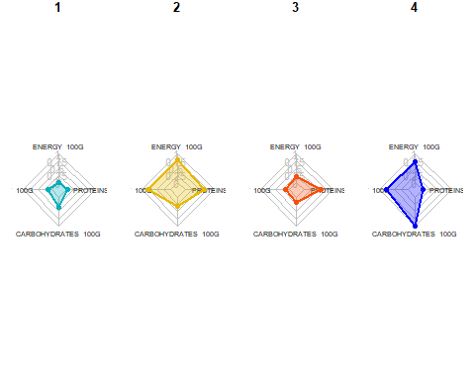

par(op)

# Visualizar los productos más cercanos al centroide que representan cada cluster top10

# Realizar clustering en el dataframe  
set.seed(123)  
df_top <- df_seitan  
km_clusters <- kmeans(x = df_top[, c("ENERGY_100G", "FAT_100G", "CARBOHYDRATES_100G", "PROTEINS_100G")], centers = 4, nstart = 50)  
  
# Obtener las asignaciones de clúster  
cluster_assignments <- km_clusters$cluster  
  
# Agregar las asignaciones de clúster al dataframe  
df_top$cluster <- cluster_assignments  
  
# Inicializar una lista para almacenar los productos más cercanos a cada centroide  
closest_products <- vector("list", max(cluster_assignments))  
  
# Encontrar los productos más cercanos a cada centroide  
for (cluster in 1:max(cluster_assignments)) {  
 cluster_center <- km_clusters$centers[cluster, ]  
 distances <- apply(df_top[, c("ENERGY_100G", "FAT_100G", "CARBOHYDRATES_100G", "PROTEINS_100G")], 1, function(row) {  
 sum((row - cluster_center)^2)  
 })  
 closest_products[[cluster]] <- head(order(distances), 10)  
}  
  
# Imprimir los productos más cercanos a cada centroide  
for (cluster in 1:max(cluster_assignments)) {  
 cat("Cluster", cluster, ":\n")  
 print(df_top[closest_products[[cluster]], c("PRODUCT_NAME", "ENERGY_100G", "FAT_100G", "CARBOHYDRATES_100G", "PROTEINS_100G")])  
 cat("\n")  
}

## Cluster 1 :  
## PRODUCT_NAME ENERGY_100G FAT_100G  
## 7673 CROCCHETTA DI SEITAN 649 2.0  
## 2116 ARROSTO DI SEITAN 653 1.4  
## 5972 SEITAN VEGGIE-HACHE 653 1.5  
## 5977 SEITAN MET MARROKAANSE KRUIDEN 653 1.5  
## 8523 BIO BURGUER VEGETAL SEITAN AL CURRY 649 6.9  
## 8538 BIO MAXI BURGUER VEGETAL, SEITAN AL CURRY 649 6.9  
## 5708 SEITANGEHAKT 636 0.9  
## 1538 SEITAN 636 1.0  
## 4363 SEITAN, DURCHSCHNITT 636 1.0  
## 6031 VEGAN BURGER SEITAN WITH CHEESE FLAVOR 657 5.0  
## CARBOHYDRATES_100G PROTEINS_100G  
## 7673 14.0 19  
## 2116 12.0 23  
## 5972 13.0 21  
## 5977 13.0 21  
## 8523 9.8 11  
## 8538 9.8 11  
## 5708 7.8 28  
## 1538 5.6 30  
## 4363 5.6 30  
## 6031 13.0 14  
##   
## Cluster 2 :  
## PRODUCT_NAME ENERGY_100G FAT_100G  
## 8547 SALCHIVEGGIE SEITAN Y TOFU 1071 12.0  
## 4784 BISTECCA DI SEITAN BIO ALLA MEDITERRANEA 1059 14.0  
## 7869 AFFETTATO VEGETALE DI SEITAN E TOFU 1075 14.7  
## 7864 AFFETTATO VEGETALE DI SEITAN E TOFU 1075 15.0  
## 1976 SEITAN TOFU 1079 14.8  
## 8535 BIO SEITAN Y TOFU TRADICIONAL 1084 15.0  
## 8385 SEITAN CON TOFU 1086 15.0  
## 8536 SEITAN Y TOFU TRADICIONAL 1088 15.0  
## 8795 SEITAN BIO 1088 15.0  
## 7651 CHARCUTERIE DE SEITAN 1042 12.0  
## CARBOHYDRATES_100G PROTEINS_100G  
## 8547 10.0 26.0  
## 4784 11.0 19.0  
## 7869 7.5 23.0  
## 7864 7.6 23.0  
## 1976 6.8 23.1  
## 8535 6.8 23.0  
## 8385 6.9 23.0  
## 8536 6.8 23.0  
## 8795 6.8 23.0  
## 7651 9.9 24.0  
##   
## Cluster 3 :  
## PRODUCT_NAME ENERGY_100G FAT_100G CARBOHYDRATES_100G  
## 8787 SEITAN NATURAL VEGANO 444 1.00 4.200000  
## 792 CUBED SEITAN WHEAT PROTEIN 443 0.00 4.705882  
## 7870 SEITAN INCREDIBILE 448 1.10 8.300000  
## 7515 SEITAN BIOLOGICO AL NATURALE 448 1.10 8.300000  
## 453 SEITAN 448 0.77 9.520000  
## 6033 SEITAN NATURAL 452 1.30 1.900000  
## 2239 SEITAN GOURMET 456 1.50 6.000000  
## 2235 SEITAN GOUTMET 456 1.50 6.000000  
## 2236 SEITAN GOURMET ORIGINAL 456 1.50 6.000000  
## 2241 SEITAN GOURMET 456 1.50 6.000000  
## PROTEINS_100G  
## 8787 20.00000  
## 792 21.17647  
## 7870 16.00000  
## 7515 16.00000  
## 453 17.86000  
## 6033 21.50000  
## 2239 17.50000  
## 2235 18.00000  
## 2236 18.00000  
## 2241 18.00000  
##   
## Cluster 4 :  
## PRODUCT_NAME ENERGY_100G FAT_100G CARBOHYDRATES_100G  
## 2164 SEITAN ALLA PIASTRA 879 7.7000 11.7000  
## 1493 SEITAN 865 8.6667 10.0000  
## 4913 SEITAN AUFSCHNITT SPICY BEANS 864 6.8000 9.3000  
## 2183 COTOLETTA DI SEITAN DORATA 879 4.0000 17.0000  
## 4458 SEITAN 883 9.4000 8.6000  
## 4910 SEITAN GESCHNETZELTES 883 6.8000 8.0000  
## 4921 SEITAN HACK 883 6.8000 8.0000  
## 4456 MEDAILLONS DE SEITAN 866 6.6000 4.1000  
## 1494 SEITAN VEGE-POULET 886 8.2353 10.5882  
## 4908 SEITAN GERAUCHERT 862 7.1000 5.0000  
## PROTEINS_100G  
## 2164 23.3000  
## 1493 22.0000  
## 4913 25.2000  
## 2183 18.0000  
## 4458 22.4000  
## 4910 28.0000  
## 4921 28.0000  
## 4456 31.4000  
## 1494 23.5294  
## 4908 29.3000

##### TOfu

fviz_eig(tofu_pca, ncp = 6, addlabels = T, main = "Variance explained by each dimensions TOfu")

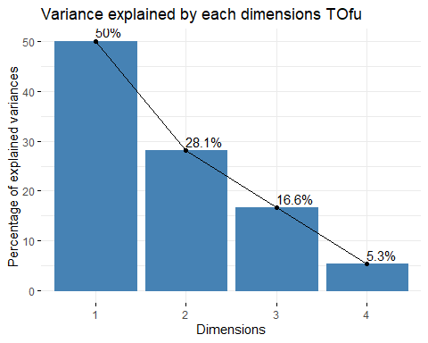

library(ggthemes)  
tofu_a <- data.frame(tofu_pca$ind$coord[,1:3])  
tofu_b <- cbind(tofu_a, lof_score = tofu_lof)  
#tofu_b <- cbind(tofu_a, fraud = tofu_clean$, lof_score = tofu_clean$lof)  
  
tofu_lof_visual <- ggplot(tofu_b, aes(x=Dim.1 ,y=Dim.2)) +   
 geom_point(aes(size=lof_score)) +  
 ggtitle("LOF Score Distribution Tofu")+  
 theme_minimal()  
  
tofu_lof_visual

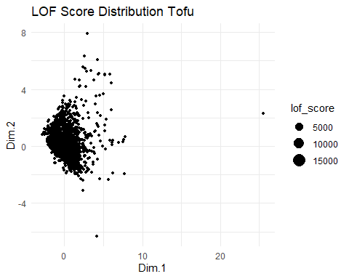

summary(tofu_b)

## Dim.1 Dim.2 Dim.3 lof_score   
## Min. :-2.8170 Min. :-6.3239 Min. :-6.57541 Min. :0.9036   
## 1st Qu.:-0.8214 1st Qu.:-0.6949 1st Qu.:-0.25797 1st Qu.:1.0000   
## Median :-0.1787 Median :-0.2655 Median : 0.01589 Median :1.0532   
## Mean : 0.0000 Mean : 0.0000 Mean : 0.00000 Mean : Inf   
## 3rd Qu.: 0.6344 3rd Qu.: 0.4581 3rd Qu.: 0.30434 3rd Qu.:1.2100   
## Max. :25.5570 Max. : 7.8974 Max. : 6.35320 Max. : Inf

tofu_b %>%  
 filter(lof_score <= 1.75) %>%   
 ggplot( aes(x=lof_score)) +  
 geom_density( color="#e9ecef", fill = "#c90076", alpha=0.7) +  
 scale_fill_manual(values="#8fce00") +  
 xlab("LOF Score")+  
 ggtitle("LOF Score Distribution Tofu")+  
 theme_minimal() +  
 labs(fill="")

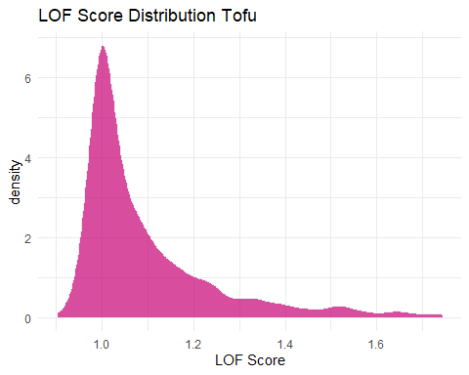

quantile(tofu_b$lof_score, probs = c(0, 0.8))

## 0% 80%   
## 0.9036087 1.2815631

tofu_b <- tofu_b %>%   
 mutate(outlier = ifelse(lof_score > 1.2815631, 1, 0))  
  
tofu_lof_visual_b <- ggplot(tofu_b, aes(x=Dim.1 ,y=Dim.2, color=outlier)) +   
 geom_point() +  
 ggtitle("LOF Score Distribution Tofu")+  
 theme_minimal()  
  
tofu_lof_visual_b

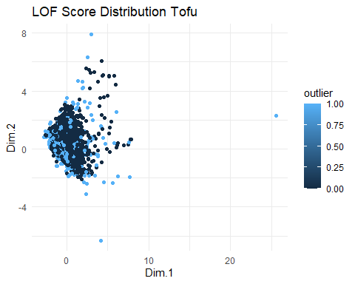

outliers <- tofu_b[tofu_b$outlier==1,]  
nooutliers <- tofu_b[tofu_b$outlier==0,]

df_tofu <- df_tofu[tofu_lof < 1.2822731,]  
df_tofu_outliers <- df_tofu[tofu_lof >= 1.2822731,]

# Eliminar valores atipicos univariantes

remove_outliers <- function(data, column, sd_threshold = 2) {  
 data[abs(scale(data[[column]])) < sd_threshold, ]  
}  
  
columns_to_check <- 3:ncol(df_tofu)  
for (column in columns_to_check) {  
 df_tofu <- remove_outliers(df_tofu, column)  
}

# Obtener las columnas cuantitativas del dataframe  
columnas_cuantitativas <- sapply(df_tofu, is.numeric)  
  
# Crear un histograma para cada columna cuantitativa  
for (columna in names(df_tofu[columnas_cuantitativas])) {  
 plot_data <- df_tofu[, columna]  
 p <- ggplot(data.frame(x = plot_data), aes(x)) +  
 geom_histogram(binwidth = 0.5, fill = "steelblue", color = "white") +  
 labs(title = paste("Histograma de", columna,"- Tofu"),  
 x = columna,  
 y = "Frecuencia")  
   
 print(p)  
}

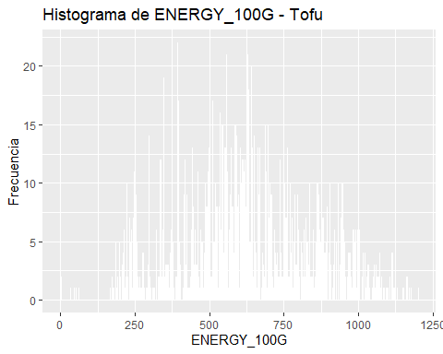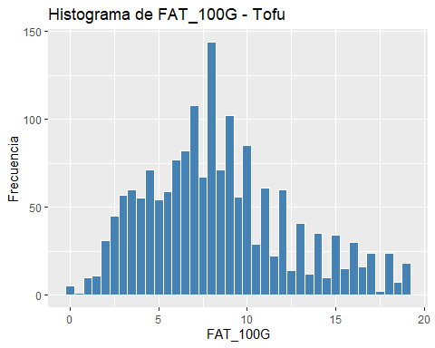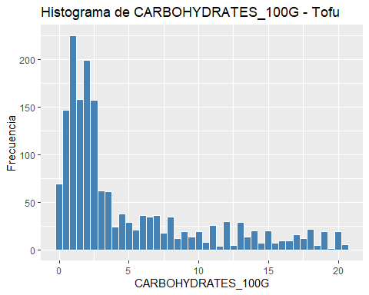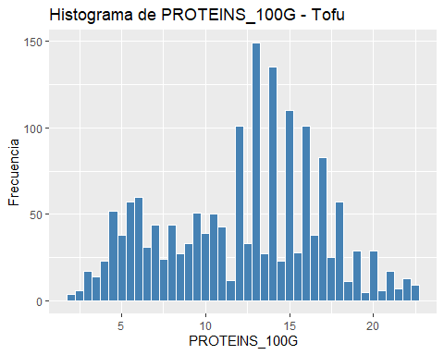

summary(as.data.frame(scale(df_tofu[,-1:-2])))

## ENERGY_100G FAT_100G CARBOHYDRATES_100G PROTEINS_100G   
## Min. :-2.74021 Min. :-2.05837 Min. :-0.9301 Min. :-2.1914   
## 1st Qu.:-0.67723 1st Qu.:-0.75421 1st Qu.:-0.7025 1st Qu.:-0.8305   
## Median :-0.05834 Median :-0.09722 Median :-0.4839 Median : 0.1723   
## Mean : 0.00000 Mean : 0.00000 Mean : 0.0000 Mean : 0.0000   
## 3rd Qu.: 0.67267 3rd Qu.: 0.56711 3rd Qu.: 0.3973 3rd Qu.: 0.7740   
## Max. : 2.64594 Max. : 2.59936 Max. : 2.9574 Max. : 2.2136

#Datos normalizados para el tofu

s_tofu <- as.data.frame(scale(df_tofu[,-1:-2]))  
# Obtener las columnas cuantitativas del dataframe  
columnas_cuantitativas <- sapply(s_tofu, is.numeric)  
  
# Crear un histograma para cada columna cuantitativa  
for (columna in names(s_tofu[columnas_cuantitativas])) {  
 plot_data <- s_tofu[, columna]  
 p <- ggplot(data.frame(x = plot_data), aes(x)) +  
 geom_histogram(binwidth = 0.5, fill = "steelblue", color = "white") +  
 labs(title = paste("Histograma de", columna,"para el Tofu"),  
 x = columna,  
 y = "Frecuencia")  
   
 print(p)  
}

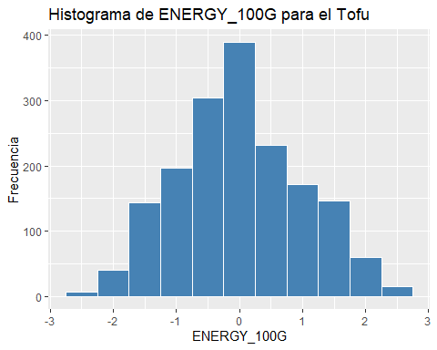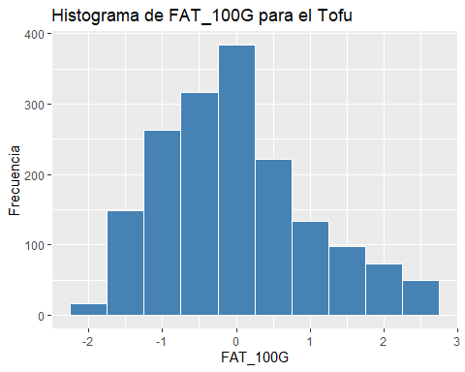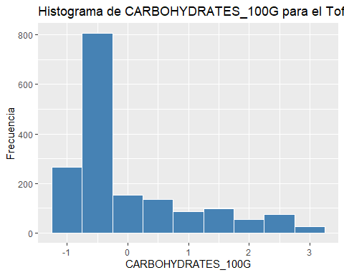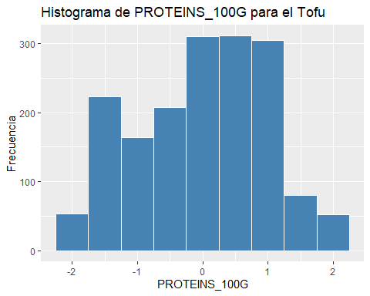

s_tofu <- scale(df_tofu[,-1:-2])  
  
# total de cluster óptimos  
elbow <- fviz_nbclust(x = s_tofu, FUNcluster = kmeans, method = "wss", k.max = 15,   
 diss = get_dist(s_tofu, method = "euclidean"), nstart = 25)  
print(elbow)

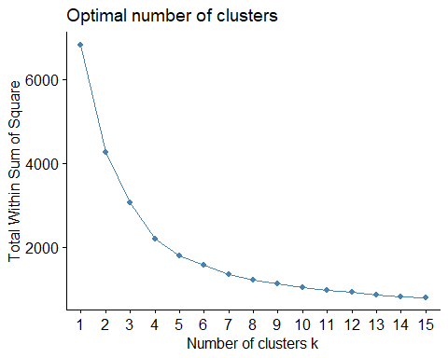

# set.seed(123)  
# km_clusters <- kmeans(x=s_tofu,centers=4,nstart=25)  
# fviz_cluster(object=km_clusters,data=s_tofu,show.clust.cent = TRUE,  
# ellipse.type="euclid",star.plot=TRUE,repel=TRUE,  
# pointsize=0.5,outlier.color="darkred") +  
# labs(title ="Resultados clustering K-means") +  
# theme_bw() +  
# theme(legend.position = "none")  
  
set.seed(123)  
km_clusters <- kmeans(x = s_tofu, centers = 4, nstart = 25)  
  
fviz_cluster(object = km_clusters, data = s_tofu, show.clust.cent = TRUE,  
 ellipse.type = "euclid", star.plot = TRUE, repel = TRUE,  
 pointsize = 0.5, outlier.color = "darkred", geom = "point") +  
 theme_bw() +  
 theme(legend.position = "none") +  
 ggtitle("Resultados clustering K-means Tofu")

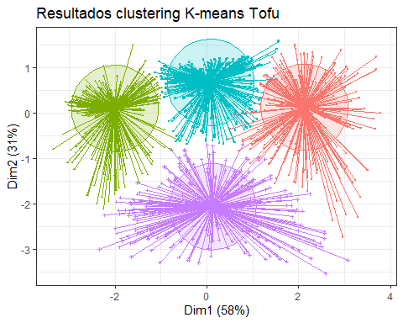

set.seed(101)  
hc_euclidea_av <- hclust(d = dist(x = s_tofu, method = "euclidean"),  
 method = "average")  
fviz_dend(x = hc_euclidea_av, k = 4, cex = 0.5,  
 k_colors = c("red","blue","green","magenta"),color_labels_by_k = T,  
 lwd = 0.2,type = "r",label_cols = rainbow(nrow(df_tofu)),  
 rect_lty = "lightblue") +  
 geom_hline(yintercept = 3.65, linetype = "dashed") +  
 labs(title = "Herarchical clustering Tofu",  
 subtitle = "Distancia euclidea, Average, k=4")

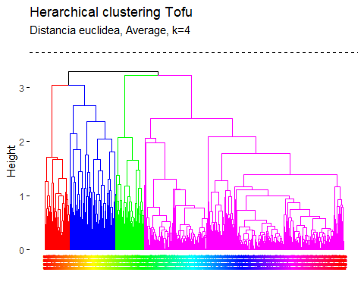

pam.res <- pam(s_tofu, 4)  
# Visualización  
fviz_cluster(pam.res, geom = "point", ellipse.type = "norm",  
 show.clust.cent = TRUE,star.plot = TRUE)+  
 labs(title = "Resultados clustering K-means Superpuestos Tofu")+ theme_bw()

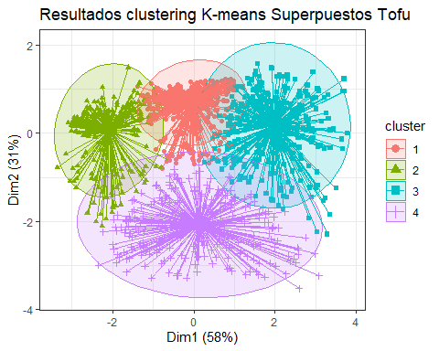 # Biplot PCA y K-Means para medir representatividad tofu

# PCA  
pca <- prcomp(df_tofu[,-1:-2], scale=TRUE)  
df_tofu.pca <- pca$x  
# Cluster over the three first PCA dimensions  
kc <- kmeans(df_tofu.pca[,1:3], 4)  
fviz_pca_biplot(pca, label="var", habillage=as.factor(kc$cluster)) +  
 labs(color=NULL) + ggtitle("") +  
 theme(text = element_text(size = 15),  
 panel.background = element_blank(),   
 panel.grid.major = element_blank(),  
 panel.grid.minor = element_blank(),  
 axis.line = element_line(colour = "black"),  
 legend.key = element_rect(fill = "white"))

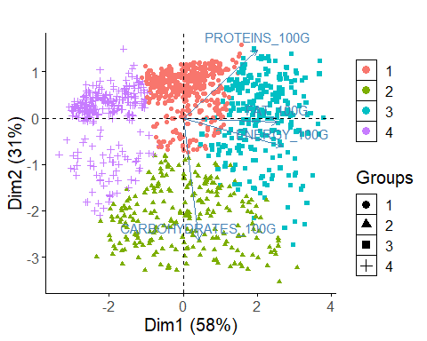

library(ggplot2)  
  
# Obtener los centroides de cada clúster  
centroids <- as.data.frame(km_clusters$centers)  
  
  
# Obtener el valor mínimo y máximo en el dataframe  
min_value <- min(centroids, na.rm = TRUE)  
max_value <- max(centroids, na.rm = TRUE)  
  
# Escalar los datos entre 0 y 1  
scaled_df <- (centroids - min_value) / (max_value - min_value)  
  
library(fmsb)  
  
  
# Define the variable ranges: maximum and minimum  
max_min <- data.frame(  
 ENERGY_100G = c(1, 0), FAT_100G = c(1, 0), CARBOHYDRATES_100G = c(1, 0),PROTEINS_100G = c(1, 0)  
)  
rownames(max_min) <- c("Max", "Min")  
  
# Bind the variable ranges to the data  
df <- rbind(max_min, scaled_df)

create_beautiful_radarchart <- function(data, color = "#00AFBB",   
 vlabels = colnames(data), vlcex = 0.7,  
 caxislabels = NULL, title = NULL, ...){  
 radarchart(  
 data, axistype = 1,  
 # Customize the polygon  
 pcol = color, pfcol = scales::alpha(color, 0.3), plwd = 2, plty = 1,  
 # Customize the grid  
 cglcol = "grey", cglty = 1, cglwd = 0.8,  
 # Customize the axis  
 axislabcol = "grey",   
 # Variable labels  
 vlcex = vlcex, vlabels = vlabels,  
 caxislabels = caxislabels, title = title, ...  
 )  
}

# Reduce plot margin using par()  
op <- par(mar = c(1, 2, 2, 1))  
create_beautiful_radarchart(df, caxislabels = c(0, .25, .5, .75, 1))

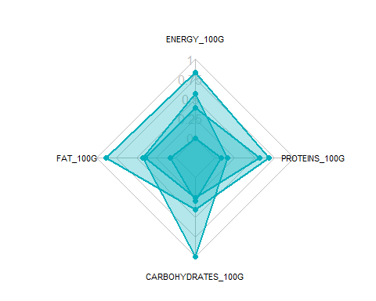

par(op)

# Reduce plot margin using par()  
op <- par(mar = c(1, 2, 2, 2))  
# Create the radar charts  
create_beautiful_radarchart(  
 data = df, caxislabels = c(0, .25, .5, .75, 1),  
 color = c("#00AFBB", "#E7B800", "#FC4E07","#7A378B")  
)  
# Add an horizontal legend  
legend(  
 x = "bottom", legend = rownames(df[-c(1,2),]), horiz = TRUE,  
 bty = "n", pch = 20 , col = c("#00AFBB", "#E7B800", "#FC4E07","#7A378B"),  
 text.col = "black", cex = 1, pt.cex = 1.5  
 )

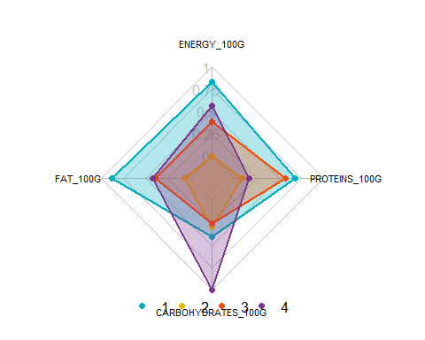

par(op)

# Define colors and titles  
colors <- c("#00AFBB", "#E7B800", "#FC4E07","blue")  
titles <- c("1", "2", "3","4")  
  
# Reduce plot margin using par()  
# Split the screen in 3 parts  
op <- par(mar = c(1, 1, 1, 1))  
  
par(mfrow = c(1,4))  
  
# Create the radar chart  
for(i in 1:4){  
 create_beautiful_radarchart(  
 data = df[c(1, 2, i+2), ], caxislabels = c(0, .25, .5, .75, 1),  
 color = colors[i], title = titles[i]  
 )  
}

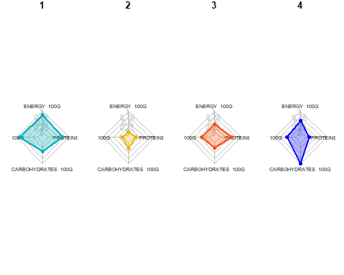

par(op)

# Visualizar los productos más cercanos al centroide que representan cada cluster top10

# Realizar clustering en el dataframe  
set.seed(123)  
df_top <- df_tofu  
km_clusters <- kmeans(x = df_top[, c("ENERGY_100G", "FAT_100G", "CARBOHYDRATES_100G", "PROTEINS_100G")], centers = 4, nstart = 50)  
  
# Obtener las asignaciones de clúster  
cluster_assignments <- km_clusters$cluster  
  
# Agregar las asignaciones de clúster al dataframe  
df_top$cluster <- cluster_assignments  
  
# Inicializar una lista para almacenar los productos más cercanos a cada centroide  
closest_products <- vector("list", max(cluster_assignments))  
  
# Encontrar los productos más cercanos a cada centroide  
for (cluster in 1:max(cluster_assignments)) {  
 cluster_center <- km_clusters$centers[cluster, ]  
 distances <- apply(df_top[, c("ENERGY_100G", "FAT_100G", "CARBOHYDRATES_100G", "PROTEINS_100G")], 1, function(row) {  
 sum((row - cluster_center)^2)  
 })  
 closest_products[[cluster]] <- head(order(distances), 10)  
}  
  
# Imprimir los productos más cercanos a cada centroide  
for (cluster in 1:max(cluster_assignments)) {  
 cat("Cluster", cluster, ":\n")  
 print(df_top[closest_products[[cluster]], c("PRODUCT_NAME", "ENERGY_100G", "FAT_100G", "CARBOHYDRATES_100G", "PROTEINS_100G")])  
 cat("\n")  
}

## Cluster 1 :  
## PRODUCT_NAME ENERGY_100G FAT_100G CARBOHYDRATES_100G  
## 385 MEDIUM FIRM TOFU 295 3.529412 2.352941  
## 723 TOFU 295 3.529412 2.352941  
## 730 HOUSE FOODS TOFU REGULAR 295 3.529412 2.352941  
## 735 TOFU 295 3.529412 2.352941  
## 749 TOFU MEDIUM FIRM 295 3.529412 2.352941  
## 1429 ORGANIC SILKEN TOFU 295 3.529412 2.352941  
## 1432 PULMUONE TOFU 295 3.529412 2.352941  
## 736 SOFT TOFU 295 3.529412 2.352941  
## 1577 FIRM TOFU 295 3.529412 2.352941  
## 1796 TOFU 295 3.529412 2.352941  
## PROTEINS_100G  
## 385 7.058824  
## 723 7.058824  
## 730 7.058824  
## 735 7.058824  
## 749 7.058824  
## 1429 7.058824  
## 1432 7.058824  
## 736 5.882353  
## 1577 8.235294  
## 1796 8.235294  
##   
## Cluster 2 :  
## PRODUCT_NAME ENERGY_100G FAT_100G CARBOHYDRATES_100G  
## 6719 TOFU FUME 707 10.0000 3.20  
## 2014 BIO-TOFU 707 9.5000 2.00  
## 2346 BIO TOFU GERAUCHERT 707 9.5000 2.00  
## 5122 RAUCHER-TOFU 707 9.5000 2.00  
## 5084 BIO-TOFU GERAUCHERT 708 9.7143 2.00  
## 1800 TOFU YU, TERIYAKI TOFU SUSHI 703 10.1800 7.96  
## 4832 BIO TOFU GERAUCHERT 704 9.5000 2.00  
## 5070 RAUCHER TOFU SCHNITTFEST 704 9.5000 2.00  
## 5100 RAUCHER-TOFU KRAFTIG 704 9.5000 2.00  
## 2618 TOFU NATURE 705 9.8000 0.70  
## PROTEINS_100G  
## 6719 16.0000  
## 2014 18.0000  
## 2346 18.0000  
## 5122 18.0000  
## 5084 18.2857  
## 1800 15.4900  
## 4832 18.0000  
## 5070 18.0000  
## 5100 18.0000  
## 2618 18.0000  
##   
## Cluster 3 :  
## PRODUCT_NAME ENERGY_100G FAT_100G CARBOHYDRATES_100G  
## 7389 COTOLETTA DI TOFU 950 14.00 12.00  
## 7571 COTOLETTA DI TOFU E SEITAN 946 11.79 10.80  
## 7562 COTOLETTA DI TOFU E SEITAN 946 11.70 10.80  
## 8407 SALCHICHAS TOFU FRANKFURT 950 13.47 5.44  
## 8698 HAPPYBURGER TOFU CHAMPIGNON 954 14.00 13.00  
## 6751 QUINOA TOFU BALLS 950 14.00 12.00  
## 8143 VEGEBURGER DE TOFU Y CHAMPINONES 954 13.70 13.10  
## 8161 VEGEBURGER DE TOFU Y CHAMPINONES 954 13.70 13.10  
## 8686 VEGBURGUER TOFU Y CHAMPINONES 954 13.70 13.10  
## 5446 FISH TOFU 946 15.40 11.20  
## PROTEINS_100G  
## 7389 12.00  
## 7571 15.60  
## 7562 15.60  
## 8407 20.61  
## 8698 11.00  
## 6751 9.00  
## 8143 10.70  
## 8161 10.70  
## 8686 10.70  
## 5446 10.60  
##   
## Cluster 4 :  
## PRODUCT_NAME ENERGY_100G FAT_100G  
## 8662 TOFU CON SEMILLA DE AMAPOLA 527 6.80  
## 695 ORGANIC FIRM TOFU 531 6.33  
## 807 O ORGANICS, ORGANIC EXTRA FIRM CUBED TOFU 531 6.33  
## 8399 ORGANIC TOFU JAPONES 527 8.00  
## 4530 TOFU TERIYAKI 531 7.00  
## 4313 FETO TOFU FERMENTE AUX HERBES 527 6.40  
## 4608 BIO TOFU 527 7.90  
## 4611 BIO TOFU NATURE 527 7.90  
## 4697 TOFU NATUR 527 7.90  
## 6437 BIO TOFU AL NATURALE 527 7.90  
## CARBOHYDRATES_100G PROTEINS_100G  
## 8662 3.3 12.20  
## 695 3.8 12.66  
## 807 3.8 12.66  
## 8399 0.7 12.26  
## 4530 3.0 13.00  
## 4313 1.9 15.00  
## 4608 0.0 13.00  
## 4611 0.0 13.00  
## 4697 0.0 13.00  
## 6437 0.0 13.00

#### SOja

fviz_eig(soja_pca, ncp = 6, addlabels = T, main = "Variance explained by each dimensions - Soja")

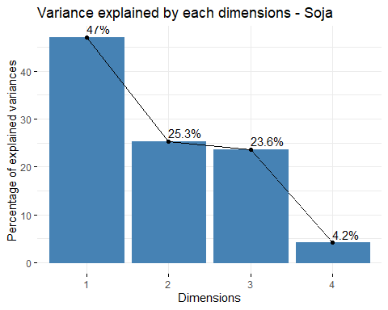

library(ggthemes)  
soja_a <- data.frame(soja_pca$ind$coord[,1:3])  
soja_b <- cbind(soja_a, lof_score = soja_lof)  
#soja_b <- cbind(soja_a, fraud = soja_clean$, lof_score = soja_clean$lof)  
  
soja_lof_visual <- ggplot(soja_b, aes(x=Dim.1 ,y=Dim.2)) +   
 geom_point(aes(size=lof_score)) +  
 ggtitle("LOF Score Distribution - Soja")+  
 theme_minimal()  
  
soja_lof_visual

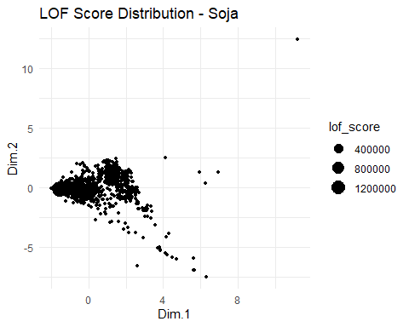

summary(soja_b)

## Dim.1 Dim.2 Dim.3 lof_score   
## Min. :-1.9743 Min. :-7.50403 Min. :-3.59918 Min. :0.8579   
## 1st Qu.:-1.2351 1st Qu.:-0.34531 1st Qu.:-0.35626 1st Qu.:1.0058   
## Median :-0.3107 Median :-0.03605 Median : 0.01204 Median :1.0928   
## Mean : 0.0000 Mean : 0.00000 Mean : 0.00000 Mean : Inf   
## 3rd Qu.: 1.1951 3rd Qu.: 0.38722 3rd Qu.: 0.32017 3rd Qu.:1.3530   
## Max. :11.2007 Max. :12.42671 Max. :18.73336 Max. : Inf

soja_b %>%  
 filter(lof_score <= 1.75) %>%   
 ggplot( aes(x=lof_score)) +  
 geom_density( color="#e9ecef", fill = "#c90076", alpha=0.7) +  
 scale_fill_manual(values="#8fce00") +  
 xlab("LOF Score")+  
 ggtitle("LOF Score Distribution - Soja")+  
 theme_minimal() +  
 labs(fill="")

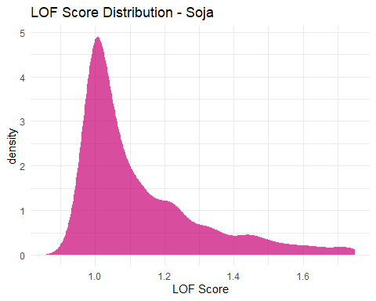

quantile(soja_b$lof_score, probs = c(0, 0.8))

## 0% 80%   
## 0.857934 1.485425

soja_b <- soja_b %>%   
 mutate(outlier = ifelse(lof_score > 1.485425, 1, 0))  
  
soja_lof_visual_b <- ggplot(soja_b, aes(x=Dim.1 ,y=Dim.2, color=outlier)) +   
 geom_point() +  
 ggtitle("LOF Score Distribution - Soja")+  
 theme_minimal()  
  
soja_lof_visual_b

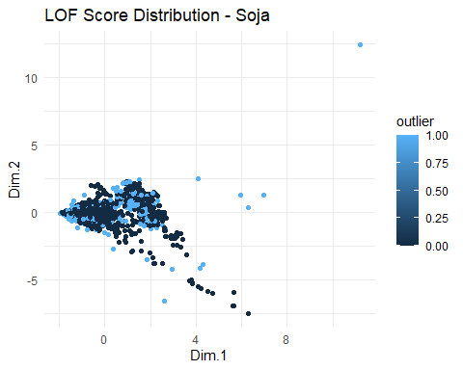

outliers <- soja_b[soja_b$outlier==1,]  
nooutliers <- soja_b[soja_b$outlier==0,]

df_soja <- df_soja[soja_lof < 1.485425,]  
df_soja_outliers <- df_soja[soja_lof >= 1.485425,]

# Eliminar valores atipicos univariantes

remove_outliers <- function(data, column, sd_threshold = 2) {  
 data[abs(scale(data[[column]])) < sd_threshold, ]  
}  
  
columns_to_check <- 3:ncol(df_soja)  
for (column in columns_to_check) {  
 df_soja <- remove_outliers(df_soja, column)  
}

# Obtener las columnas cuantitativas del dataframe  
columnas_cuantitativas <- sapply(df_soja, is.numeric)  
  
# Crear un histograma para cada columna cuantitativa  
for (columna in names(df_soja[columnas_cuantitativas])) {  
 plot_data <- df_soja[, columna]  
 p <- ggplot(data.frame(x = plot_data), aes(x)) +  
 geom_histogram(binwidth = 0.5, fill = "steelblue", color = "white") +  
 labs(title = paste("Histograma de", columna,"- Soja"),  
 x = columna,  
 y = "Frecuencia")  
   
 print(p)  
}

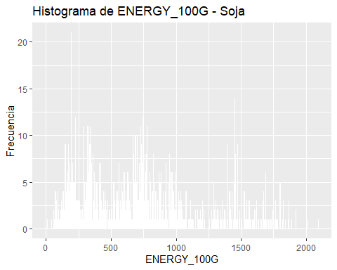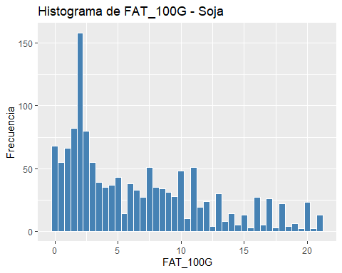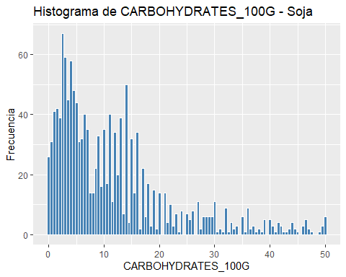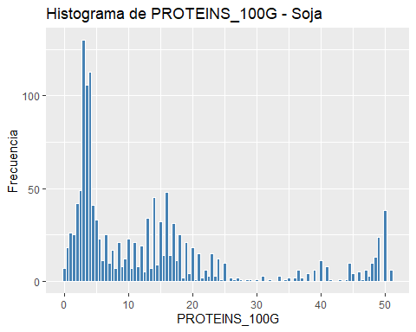

summary(as.data.frame(scale(df_soja[,-1:-2])))

## ENERGY_100G FAT_100G CARBOHYDRATES_100G PROTEINS_100G   
## Min. :-1.53946 Min. :-1.1866 Min. :-1.0813 Min. :-0.9730   
## 1st Qu.:-0.82857 1st Qu.:-0.8203 1st Qu.:-0.7347 1st Qu.:-0.7118   
## Median :-0.08933 Median :-0.2708 Median :-0.2663 Median :-0.3708   
## Mean : 0.00000 Mean : 0.0000 Mean : 0.0000 Mean : 0.0000   
## 3rd Qu.: 0.54087 3rd Qu.: 0.6450 3rd Qu.: 0.3613 3rd Qu.: 0.2605   
## Max. : 3.02243 Max. : 2.6596 Max. : 3.6024 Max. : 2.7275

#Datos normalizados para el soja

s_soja <- as.data.frame(scale(df_soja[,-1:-2]))  
# Obtener las columnas cuantitativas del dataframe  
columnas_cuantitativas <- sapply(s_soja, is.numeric)  
  
# Crear un histograma para cada columna cuantitativa  
for (columna in names(s_soja[columnas_cuantitativas])) {  
 plot_data <- s_soja[, columna]  
 p <- ggplot(data.frame(x = plot_data), aes(x)) +  
 geom_histogram(binwidth = 0.5, fill = "steelblue", color = "white") +  
 labs(title = paste("Histograma de", columna,"- Soja"),  
 x = columna,  
 y = "Frecuencia")  
   
 print(p)  
}

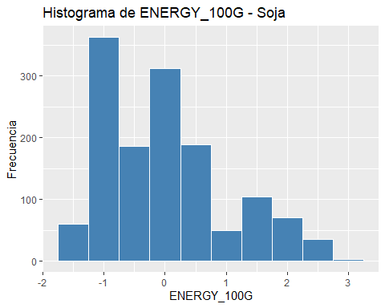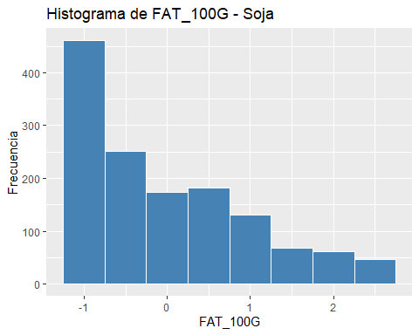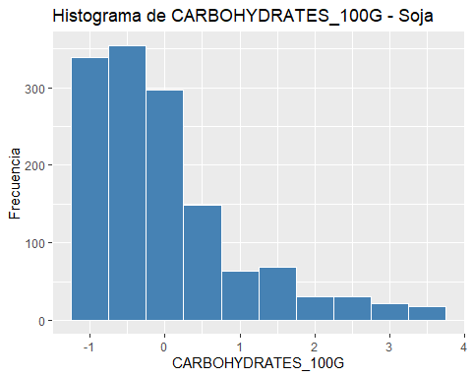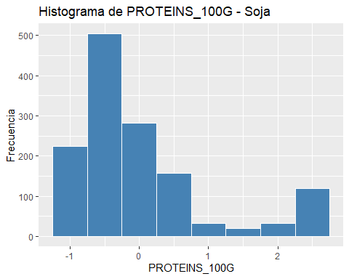

s_soja <- scale(df_soja[,-1:-2])  
  
# total de cluster óptimos  
elbow <- fviz_nbclust(x = s_soja, FUNcluster = kmeans, method = "wss", k.max = 15,   
 diss = get_dist(s_soja, method = "euclidean"), nstart = 25)  
print(elbow)

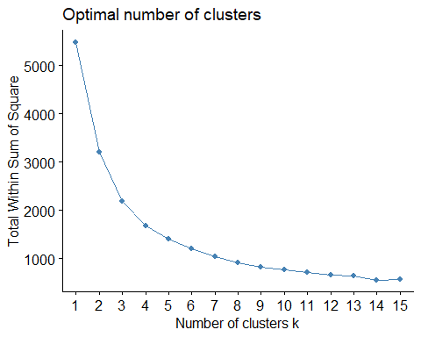

# set.seed(123)  
# km_clusters <- kmeans(x=s_soja,centers=4,nstart=25)  
# fviz_cluster(object=km_clusters,data=s_soja,show.clust.cent = TRUE,  
# ellipse.type="euclid",star.plot=TRUE,repel=TRUE,  
# pointsize=0.5,outlier.color="darkred") +  
# labs(title ="Resultados clustering K-means") +  
# theme_bw() +  
# theme(legend.position = "none")  
  
set.seed(123)  
km_clusters <- kmeans(x = s_soja, centers = 4, nstart = 50)  
  
fviz_cluster(object = km_clusters, data = s_soja, show.clust.cent = TRUE,  
 ellipse.type = "euclid", star.plot = TRUE, repel = TRUE,  
 pointsize = 0.5, outlier.color = "darkred", geom = "point") +  
 theme_bw() +  
 theme(legend.position = "none") +  
 ggtitle("Resultados clustering K-means - Soja")

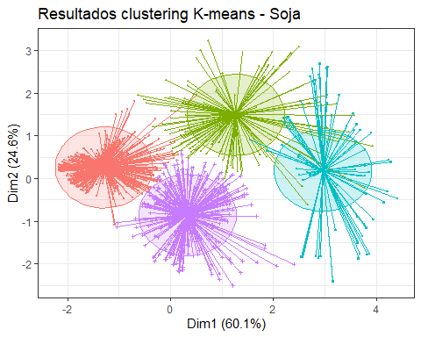

set.seed(101)  
hc_euclidea_av <- hclust(d = dist(x = s_soja, method = "euclidean"),  
 method = "average")  
fviz_dend(x = hc_euclidea_av, k = 4, cex = 0.5,  
 k_colors = c("red","blue","green","magenta"),color_labels_by_k = T,  
 lwd = 0.2,type = "r",label_cols = rainbow(nrow(df_soja)),  
 rect_lty = "lightblue") +  
 geom_hline(yintercept = 3.65, linetype = "dashed") +  
 labs(title = "Herarchical clustering Soja",  
 subtitle = "Distancia euclidea, Average, k=4")

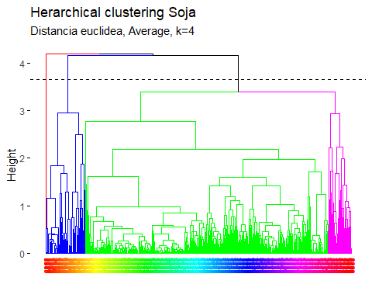

pam.res <- pam(s_soja, 4)  
# Visualización  
fviz_cluster(pam.res, geom = "point", ellipse.type = "norm",  
 show.clust.cent = TRUE,star.plot = TRUE)+  
 labs(title = "Resultados clustering K-means superpuesto Soja")+ theme_bw()

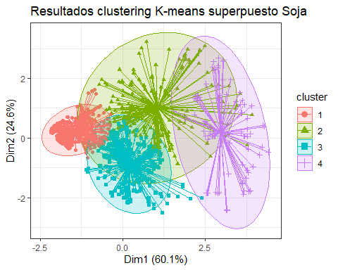 # Biplot PCA y K-Means para medir representatividad soja

# PCA  
pca <- prcomp(df_soja[,-1:-2], scale=TRUE)  
df_soja.pca <- pca$x  
# Cluster over the three first PCA dimensions  
kc <- kmeans(df_soja.pca[,1:3], 4)  
fviz_pca_biplot(pca, label="var", habillage=as.factor(kc$cluster)) +  
 labs(color=NULL) + ggtitle("") +  
 theme(text = element_text(size = 15),  
 panel.background = element_blank(),   
 panel.grid.major = element_blank(),  
 panel.grid.minor = element_blank(),  
 axis.line = element_line(colour = "black"),  
 legend.key = element_rect(fill = "white"))

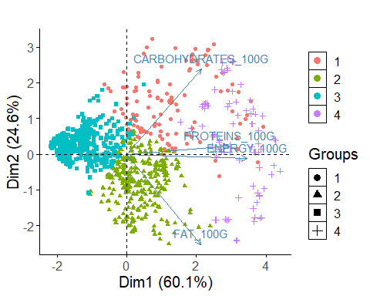

library(ggplot2)  
  
# Obtener los centroides de cada clúster  
centroids <- as.data.frame(km_clusters$centers)  
  
  
# Obtener el valor mínimo y máximo en el dataframe  
min_value <- min(centroids, na.rm = TRUE)  
max_value <- max(centroids, na.rm = TRUE)  
  
# Escalar los datos entre 0 y 1  
scaled_df <- (centroids - min_value) / (max_value - min_value)  
  
library(fmsb)  
  
  
# Define the variable ranges: maximum and minimum  
max_min <- data.frame(  
 ENERGY_100G = c(1, 0), FAT_100G = c(1, 0), CARBOHYDRATES_100G = c(1, 0),PROTEINS_100G = c(1, 0)  
)  
rownames(max_min) <- c("Max", "Min")  
  
# Bind the variable ranges to the data  
df <- rbind(max_min, scaled_df)

create_beautiful_radarchart <- function(data, color = "#00AFBB",   
 vlabels = colnames(data), vlcex = 0.7,  
 caxislabels = NULL, title = NULL, ...){  
 radarchart(  
 data, axistype = 1,  
 # Customize the polygon  
 pcol = color, pfcol = scales::alpha(color, 0.3), plwd = 2, plty = 1,  
 # Customize the grid  
 cglcol = "grey", cglty = 1, cglwd = 0.8,  
 # Customize the axis  
 axislabcol = "grey",   
 # Variable labels  
 vlcex = vlcex, vlabels = vlabels,  
 caxislabels = caxislabels, title = title, ...  
 )  
}

# Reduce plot margin using par()  
op <- par(mar = c(1, 2, 2, 1))  
create_beautiful_radarchart(df, caxislabels = c(0, .25, .5, .75, 1))

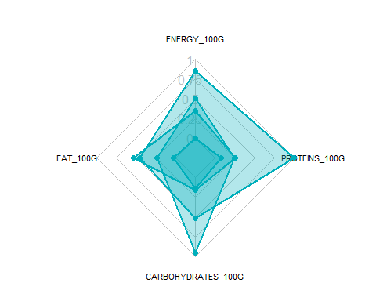

par(op)

# Reduce plot margin using par()  
op <- par(mar = c(1, 2, 2, 2))  
# Create the radar charts  
create_beautiful_radarchart(  
 data = df, caxislabels = c(0, .25, .5, .75, 1),  
 color = c("#00AFBB", "#E7B800", "#FC4E07","#7A378B")  
)  
# Add an horizontal legend  
legend(  
 x = "bottom", legend = rownames(df[-c(1,2),]), horiz = TRUE,  
 bty = "n", pch = 20 , col = c("#00AFBB", "#E7B800", "#FC4E07","#7A378B"),  
 text.col = "black", cex = 1, pt.cex = 1.5  
 )

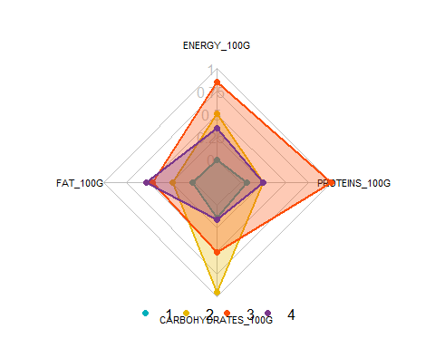

par(op)

# Define colors and titles  
colors <- c("#00AFBB", "#E7B800", "#FC4E07","blue")  
titles <- c("1", "2", "3","4")  
  
# Reduce plot margin using par()  
# Split the screen in 3 parts  
op <- par(mar = c(1, 1, 1, 1))  
  
par(mfrow = c(1,4))  
  
# Create the radar chart  
for(i in 1:4){  
 create_beautiful_radarchart(  
 data = df[c(1, 2, i+2), ], caxislabels = c(0, .25, .5, .75, 1),  
 color = colors[i], title = titles[i]  
 )  
}

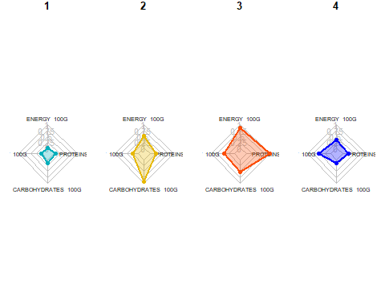

par(op)

# Visualizar los productos más cercanos al centroide que representan cada cluster top10

# Realizar clustering en el dataframe  
set.seed(123)  
df_top <- df_soja  
km_clusters <- kmeans(x = df_top[, c("ENERGY_100G", "FAT_100G", "CARBOHYDRATES_100G", "PROTEINS_100G")], centers = 4, nstart = 50)  
  
# Obtener las asignaciones de clúster  
cluster_assignments <- km_clusters$cluster  
  
# Agregar las asignaciones de clúster al dataframe  
df_top$cluster <- cluster_assignments  
  
# Inicializar una lista para almacenar los productos más cercanos a cada centroide  
closest_products <- vector("list", max(cluster_assignments))  
  
# Encontrar los productos más cercanos a cada centroide  
for (cluster in 1:max(cluster_assignments)) {  
 cluster_center <- km_clusters$centers[cluster, ]  
 distances <- apply(df_top[, c("ENERGY_100G", "FAT_100G", "CARBOHYDRATES_100G", "PROTEINS_100G")], 1, function(row) {  
 sum((row - cluster_center)^2)  
 })  
 closest_products[[cluster]] <- head(order(distances), 10)  
}  
  
# Imprimir los productos más cercanos a cada centroide  
for (cluster in 1:max(cluster_assignments)) {  
 cat("Cluster", cluster, ":\n")  
 print(df_top[closest_products[[cluster]], c("PRODUCT_NAME", "ENERGY_100G", "FAT_100G", "CARBOHYDRATES_100G", "PROTEINS_100G")])  
 cat("\n")  
}

## Cluster 1 :  
## PRODUCT_NAME ENERGY_100G FAT_100G CARBOHYDRATES_100G  
## 3165 SOJA FERMENTADA 264 2.3 6.4  
## 2895 BOULETTES DE SOJA ET TOMATES 262 1.5 6.3  
## 6816 SOJA 264 0.0 7.0  
## 4977 16G PROTEIN OHNE SOJA 268 0.3 8.8  
## 3062 SO SOJA ! BANANE-PASSION 259 2.0 7.0  
## 4772 GULASCH VEGAN MIT SOJA 259 1.1 6.5  
## 4338 SHOYU - SOJASOSSE JAPANISCHE ART 267 0.2 5.2  
## 4467 SHOYU SOJASOSSE AUS JAPAN 259 0.1 6.2  
## 2894 BOUCHEES SOJA ET LEGUMES 272 2.0 5.2  
## 2896 BOUCHEES DE SOJA ET LEGUMES 272 2.0 5.2  
## PROTEINS_100G  
## 3165 4.1  
## 2895 4.0  
## 6816 8.7  
## 4977 6.4  
## 3062 3.6  
## 4772 4.0  
## 4338 10.0  
## 4467 8.8  
## 2894 4.5  
## 2896 4.5  
##   
## Cluster 2 :  
## PRODUCT_NAME ENERGY_100G  
## 5624 LA PANEE SOJA ET BLE 981  
## 6864 LA PANEE SOJA ET BLE 981  
## 6689 GARDEN GOURMET LA PANEE SOJA ET BLE 180G 984  
## 6701 GARDEN GOURMET LA PANEE SOJA ET BLE FORMAT FAMILIAL 360G 984  
## 3231 BURGER VEGETARIEN STEAK SOJA ET MOZZARELLA 980  
## 2496 GRILL VEGETAL - NUGGETS SOJA & BLE 975  
## 6441 NUGGETS SOJA & BLE 975  
## 5718 BURGERS DE LEGUMES AU SOJA BELGE 983  
## 3390 NUGGETS SOJA ET BLE 983  
## 15 ESCALOPES PANEES DE SOJA 992  
## FAT_100G CARBOHYDRATES_100G PROTEINS_100G  
## 5624 11.66667 17.55556 12.22222  
## 6864 11.66667 17.55556 12.22222  
## 6689 11.70000 17.60000 12.30000  
## 6701 11.70000 17.60000 12.30000  
## 3231 10.00000 21.00000 13.00000  
## 2496 11.00000 14.00000 17.00000  
## 6441 11.00000 14.00000 17.00000  
## 5718 14.00000 9.20000 15.00000  
## 3390 8.00000 25.00000 13.00000  
## 15 11.00000 18.00000 14.00000  
##   
## Cluster 3 :  
## PRODUCT_NAME ENERGY_100G FAT_100G  
## 2949 PROTEINES DE SOJA GROSSES 1544 8.0  
## 3254 PROTEINES DE SOJA GROS MORCEAUX 1540 8.0  
## 3256 PROTEINE DE SOJA PETITS MORCEAUX 1540 8.0  
## 4057 PROTEINE DE SOJA 1540 8.0  
## 8051 SOJA FINA TEXTURIZADA 1531 6.0  
## 4624 SOJASCHNETZEL 1561 9.0  
## 4868 PLANET NATURE SOJA FLEISCHSCHNETZEL ART 1561 9.0  
## 9251 BIO SOJA GRANULAT 1561 9.0  
## 3364 SOJA VERT 1536 18.1  
## 8560 FIDEOS DE SOJA BIOLOGICOS 1527 5.0  
## CARBOHYDRATES_100G PROTEINS_100G  
## 2949 14.0 50.0  
## 3254 14.0 50.0  
## 3256 14.0 50.0  
## 4057 14.0 50.0  
## 8051 32.0 46.0  
## 4624 16.0 50.0  
## 4868 16.0 50.0  
## 9251 16.0 50.0  
## 3364 6.3 33.7  
## 8560 19.9 26.8  
##   
## Cluster 4 :  
## PRODUCT_NAME ENERGY_100G FAT_100G  
## 2513 CROQ' SOJA, POMME DE TERRE & EMMENTAL 674 8.1  
## 3584 GALETTES DE SOJA RECETTE MEDITERRANEENNE 678 7.6  
## 4040 BOULE DE SOJA ENROBEE CARAMEL CACAHUETE 678 6.8  
## 3619 BURGERS BLE, SOJA 674 5.9  
## 3022 STEAK DE SOJA TOMATE MOZZARELLA 674 6.5  
## 3583 GALETTES DE SOJA AUX 5 LEGUMES 682 8.0  
## 3020 STEAKS DE SOJA A LA PROVENÇALE 678 8.5  
## 3025 STEAKS DE SOJA A LA MEDITERRANEENNE 678 8.5  
## 6757 CHARCUTERIE A BASE DE SOJA ET POIS 682 11.0  
## 2500 HACHE VEGETAL (SOJA OIGNONS ET PERSIL) 674 4.5  
## CARBOHYDRATES_100G PROTEINS_100G  
## 2513 7.2 13.0  
## 3584 8.6 13.0  
## 4040 10.0 15.0  
## 3619 8.5 16.0  
## 3022 6.5 16.7  
## 3583 7.6 13.0  
## 3020 3.5 15.5  
## 3025 3.5 15.5  
## 6757 6.3 8.4  
## 2500 13.0 16.0